Assignment 4

Name – Kajal

Reg no – 21BAC10039

Campus – Vit Bhopal

Code:

1. Load the Dataset

import pandas as pd

dataset = pd.read_csv('winequality-red.csv')

2. Data preprocessing including visualization

# Display summary statistics of the dataset

summary_stats = dataset.describe()

print(summary_stats)

Output:

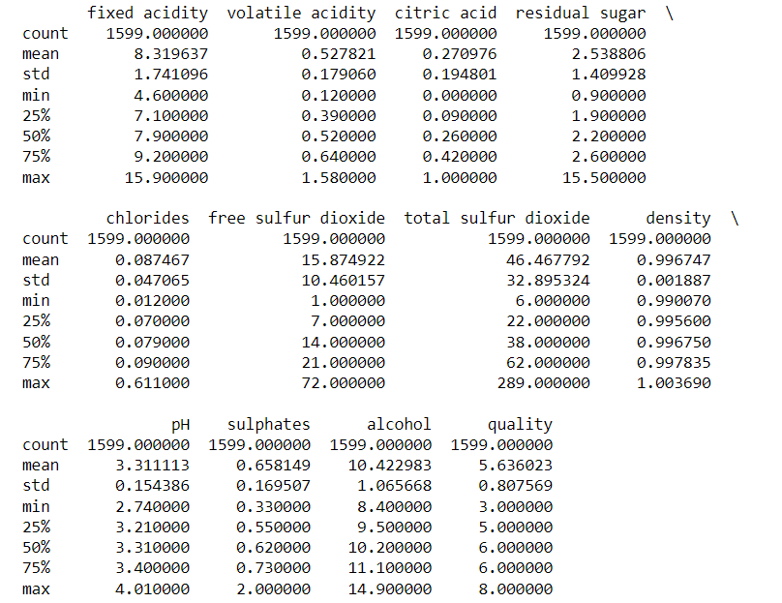

import matplotlib.pyplot as plt

import seaborn as sns

# Countplot of wine quality

plt.figure(figsize=(6, 4))

sns.countplot(data=dataset, x='quality')

plt.title('Distribution of Wine Quality')

plt.xlabel('Quality')

plt.ylabel('Count')

plt.show()

Output:

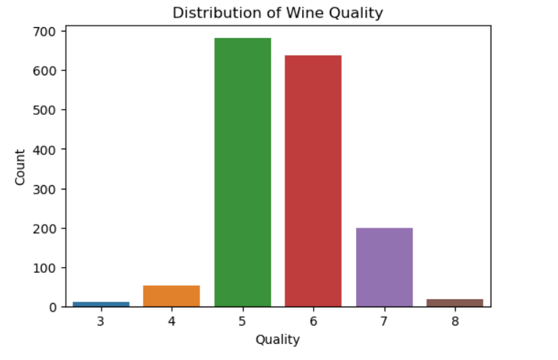

3 & 4. Machine Learning Model building and Evaluate the model

from sklearn.model_selection import train_test_split

from sklearn.ensemble import RandomForestClassifier

from sklearn.metrics import accuracy_score, classification_report

X = dataset.drop('quality', axis=1)

y = dataset['quality']

X_train, X_test, y_train, y_test = train_test_split(X, y, test_size=0.2, random_state=42)

clf = RandomForestClassifier(n_estimators=100, random_state=42)

clf.fit(X_train, y_train)

y_pred = clf.predict(X_test)

# Evaluate the model

accuracy = accuracy_score(y_test, y_pred)

classification_rep = classification_report(y_test, y_pred)

print(f'Accuracy: {accuracy:.2f}')

print('Classification Report:')

print(classification_rep)

Output:

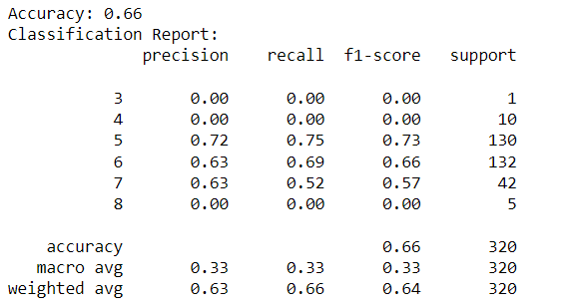

5. # Create a random observation

new_observation = pd.DataFrame({

'fixed acidity': [7.0],

'volatile acidity': [0.4],

'citric acid': [0.25],

'residual sugar': [2.0],

'chlorides': [0.045],

'free sulfur dioxide': [35.0],

'total sulfur dioxide': [120.0],

'density': [0.99],

'pH': [3.2],

'sulphates': [0.6],

'alcohol': [11.0]

})

# Use the trained model to predict the quality of the new observation

predicted_quality = clf.predict(new_observation)

print(f'Predicted Wine Quality: {predicted_quality[0]}')

Output:

